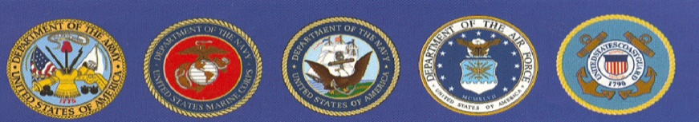

EBBETTS PASS VETERANS MEMORIAL DISTRICT

*“Honoring Those Who Have Served”*

**P.O. Box 175, Murphys, CA 95247**

MINUTES

REGULAR BOARD MEETING

September 6, 2022

CALL TO ODER: 7:00 by Redman

Directors Present: Redman, Carlon, Palmer, Padou

Employees/Guests Present: Rocco, Yeadon, Fischer

APPROVAL OF MINUTES of the Regular Board Meeting of August 2, 2022. Padou motioned to approve the minutes as submitted. 2nd by Carlon. Board Approved.

PUBLIC COMMENTS: 0

CORRESPONDENC:0

OLD SCHOOL HOUSE: No response from VUSD as of meeting date. County office of Veteran’s Affairs meets at the OSH 2nd & 4th Tuesday of each month.

MEMORIALS: Rocco to call Greg Holt in McClintock’s office, Roseville re: help with the authorization from DOD for official military logo for bricks.

CARETAKER REPORT BY YEADON: Carlon motioned to approve the repair of 24) vinyl chairs not to exceed $500. 2nd by Palmer. Board Approved.

VETERAN’S DAY CEREMONY:

* Padou motioned to go ahead with the printing and mailing to promote ceremony with expenses not to exceed $2,000. 2nd by Palmer. Board Approved.
* Carlon motioned to approve Ton @ The Bistro’s Catering Proposal as submitted. 2nd by Palmer. Board Approved.
* Palmer motioned to approve the rental for a Tent for up to $3,200. 2nd by Carlon. Board Approved
* Palmer motioned to approve the rental of tables and chairs not to exceed $2,000. 2nd by Carlon. Board Approved.
* Padou will work to get “Aurora” and her friends to help with cleanup, etc at event.

COMMUNITY EVENTS INVOLVEMENT: Michelson School Veteran’s Flag Ceremony. 11/10 @ 8:15 am.

FINANCIAL / BUDGET By Megan Fischer: Padou motioned to approve both budgets as proposed by Fischer. General Reserve Budget adding $10,000 misc revenue. 2nd by Palmer. Board Approved.

ADJOURN PUBLIC MEETING: 8:36 by Redman

The next meeting is scheduled for October 4, 2022 @ 7 pm @ EPVMD Hall.